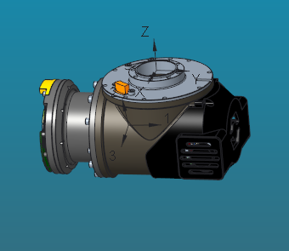

VOLUME = 6.4728590e+05 MM^3

SURFACE AREA = 4.6387327e+05 MM^2

AVERAGE DENSITY = 3.6072396e-06 KILOGRAM / MM^3

MASS = 2.3349153e+00 KILOGRAM

CENTER OF GRAVITY with respect to URDF_HIP-YAW coordinate frame:

X Y Z 3.5958550e-01 -3.3338818e+01 -5.9190309e+01 MM

INERTIA with respect to URDF_HIP-YAW coordinate frame: (KILOGRAM * MM^2)

INERTIA TENSOR:

Ixx Ixy Ixz 1.7616100e+04 9.4186953e+00 1.3703117e+00

Iyx Iyy Iyz 9.4186953e+00 1.0806842e+04 -4.7639973e+03

Izx Izy Izz 1.3703117e+00 -4.7639973e+03 9.2888415e+03

INERTIA at CENTER OF GRAVITY with respect to URDF_HIP-YAW coordinate frame: (KILOGRAM * MM^2)

INERTIA TENSOR:

Ixx Ixy Ixz 6.8405374e+03 -1.8572633e+01 -4.8325972e+01

Iyx Iyy Iyz -1.8572633e+01 2.6261815e+03 -1.5642730e+02

Izx Izy Izz -4.8325972e+01 -1.5642730e+02 6.6933354e+03

PRINCIPAL MOMENTS OF INERTIA: (KILOGRAM * MM^2)

I1 I2 I3 2.6200753e+03 6.6848161e+03 6.8551630e+03

ROTATION MATRIX from URDF_HIP-YAW orientation to PRINCIPAL AXES:

0.00484 0.29202 0.95640

0.99925 -0.03817 0.00660

0.03843 0.95565 -0.29199

ROTATION ANGLES from URDF_HIP-YAW orientation to PRINCIPAL AXES (degrees):

angles about x y z-178.705 73.019 -89.051

RADII OF GYRATION with respect to PRINCIPAL AXES:

R1 R2 R3 3.3498188e+01 5.3506823e+01 5.4184282e+01 MM

---------------------------------------------

MASS PROPERTIES OF COMPONENTS OF THE ASSEMBLY

(in assembly units and the URDF_HIP-YAW coordinate frame)

DENSITY MASS C.G.: X Y Z

CE0002A0 MATERIAL: UNKNOWN

3.60724e-06 2.33492e+00 3.59586e-01 -3.33388e+01 -5.91903e+01

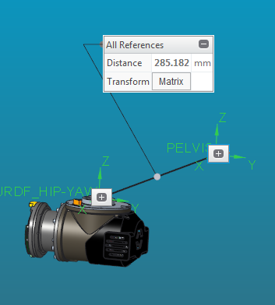

1.00000 0.0000000000 0.0000000000 250.000

0.0000000000 1.00000 0.0000000000 -125.000

0.0000000000 0.0000000000 1.00000 -56.6000